# 

Tutorail 4

Jquery is basically a dom triversal library

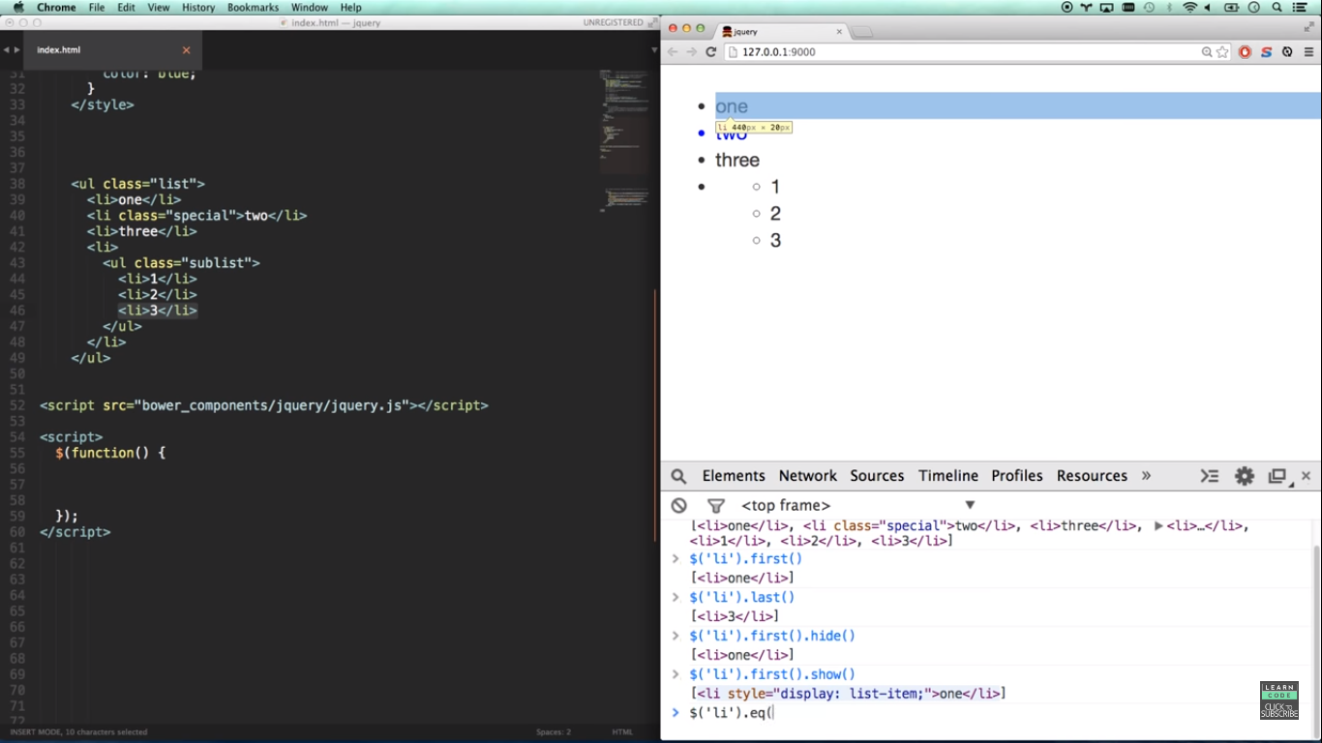

# 

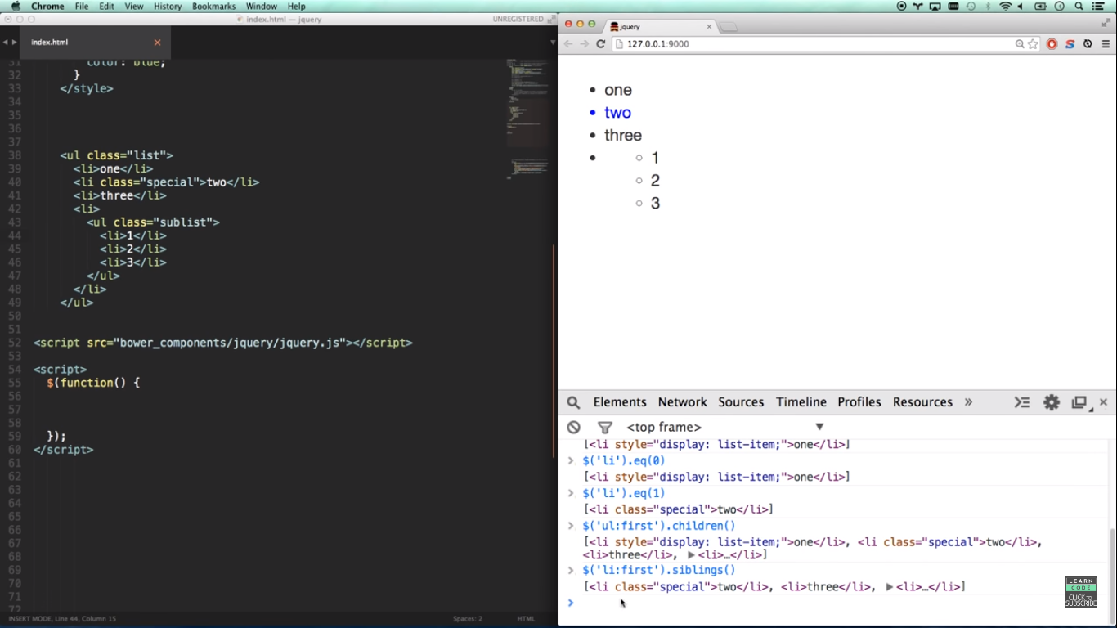

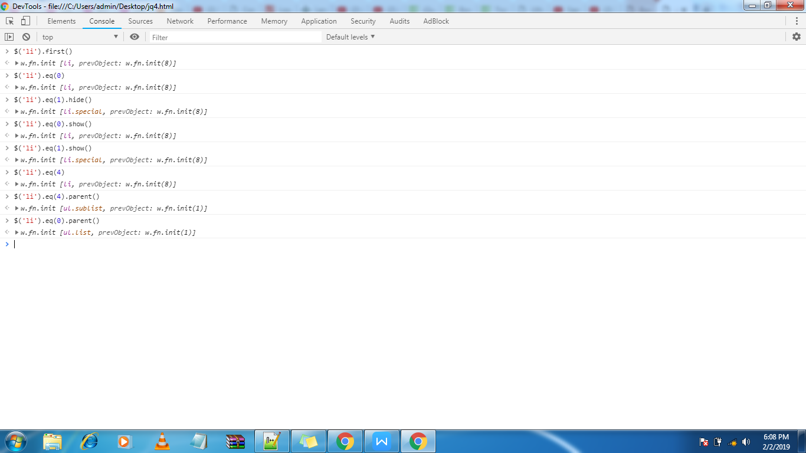

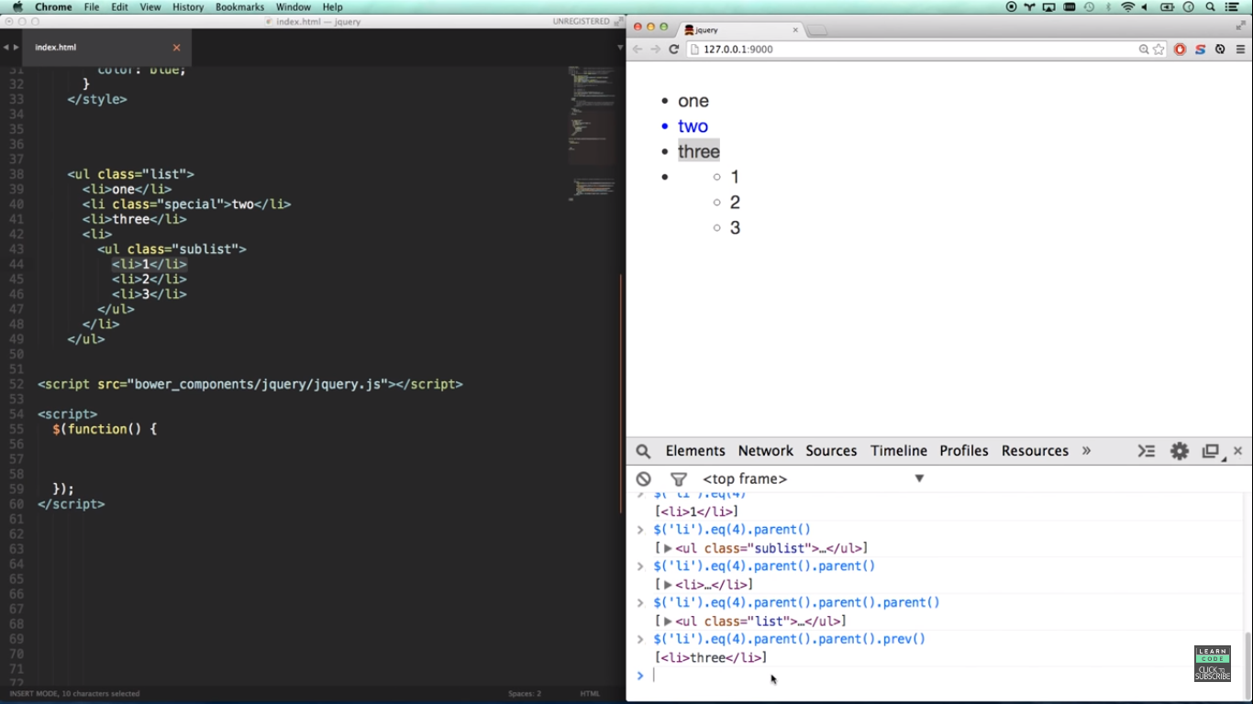

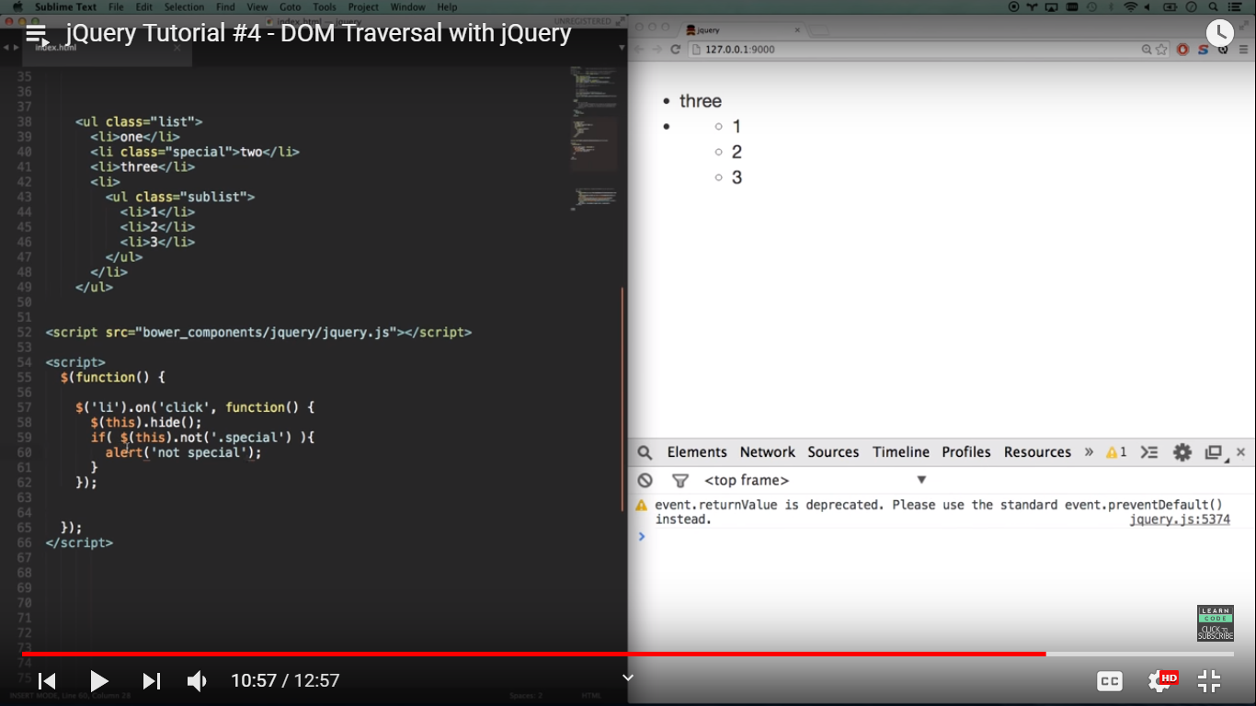

## Definition and Usage

The closest() method returns the first ancestor of the selected element.

An ancestor is a parent, grandparent, great-grandparent, and so on.

**The DOM tree:** This method traverse upwards from the current element, all the way up to the document's root element (<html>), to find the first ancestor of DOM elements.

This method is similar to [parents()](https://www.w3schools.com/jquery/traversing_parents.asp), in that they both traverse up the DOM tree. The differences are as follows:

closest()

* Begins with the current element
* Travels up the DOM tree and returns the first (single) ancestor that matches the passed expression
* The returned jQuery object contains zero or one element

parents()

* Begins with the parent element
* Travels up the DOM tree and returns all ancestors that matches the passed expression
* The returned jQuery object contains zero or more than one element

**Other related methods:**

The parent() method returns the direct parent element of the selected element.

**What if other JavaScript frameworks also use the $ sign as a shortcut?**

If two different frameworks are using the same shortcut, one of them might stop working.

The jQuery team have already thought about this, and implemented the noConflict() method

You can also create your own shortcut very easily. The noConflict() method returns a reference to jQuery, that you can save in a variable, for later use. Here is an example:

<!DOCTYPE html>

<html>

<head>

<script src="https://ajax.googleapis.com/ajax/libs/jquery/3.3.1/jquery.min.js"></script>

<script>

var jq = $.noConflict();

jq(document).ready(function(){

jq("button").click(function(){

jq("p").text("jQuery is still working!");

});

});

</script>

</head>

<body>

<p>This is a paragraph.</p>

<button>Test jQuery</button>

</body>

</html>

# jQuery Ajax Tutorial #2 - Posting data to backend (jQuery tutorial #8)

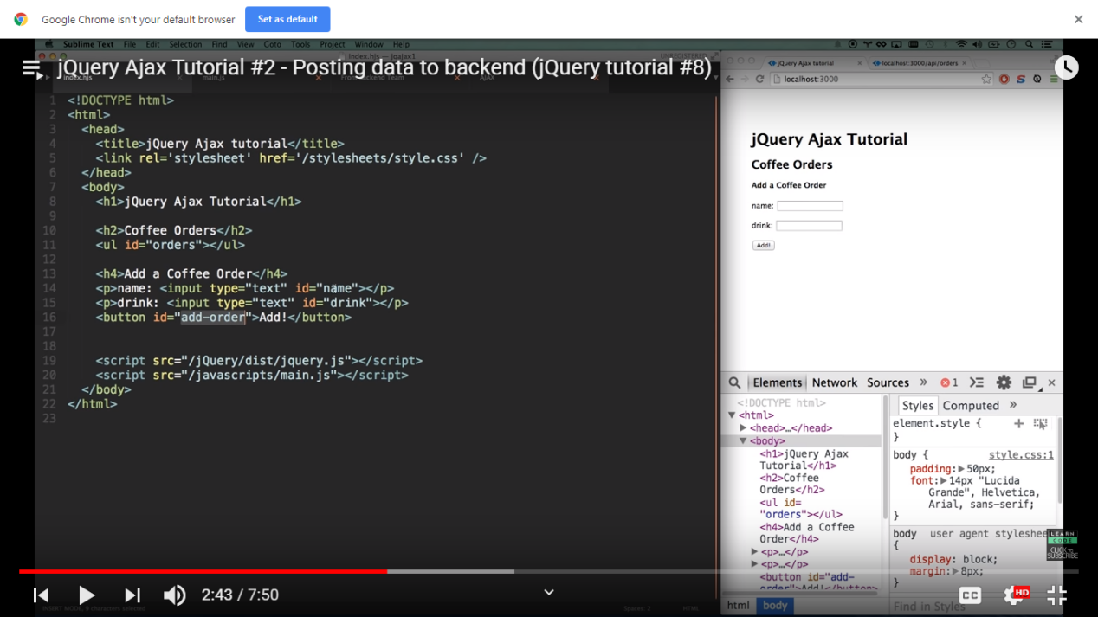

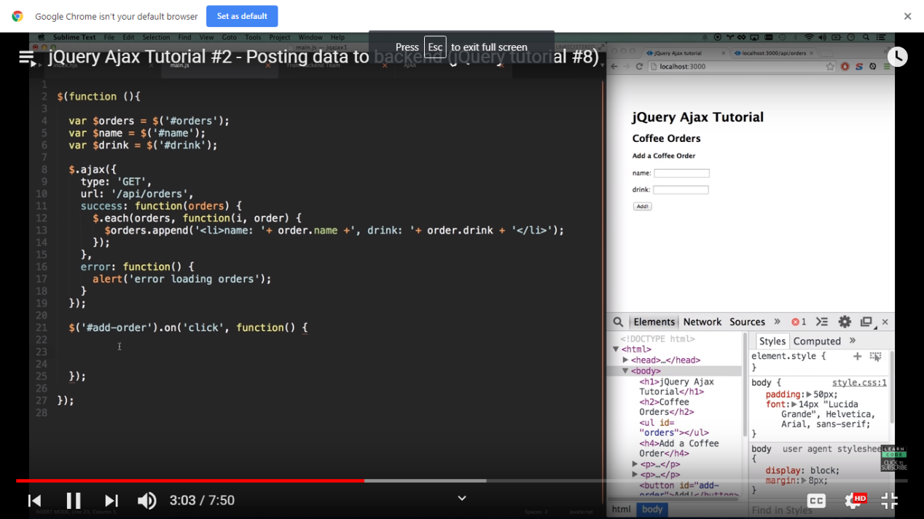

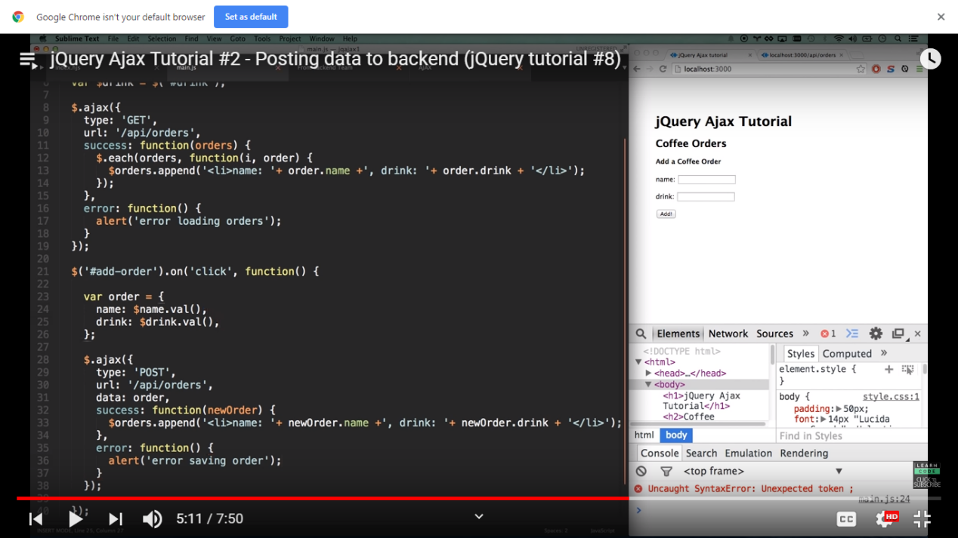

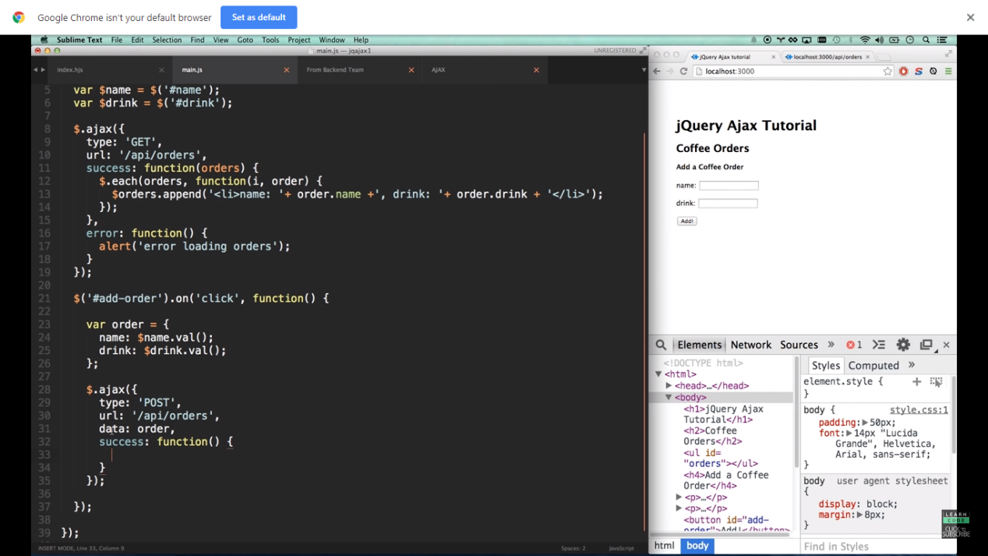

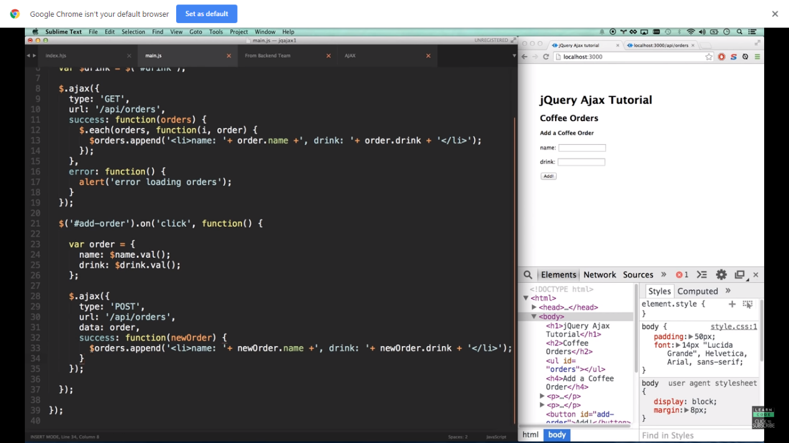

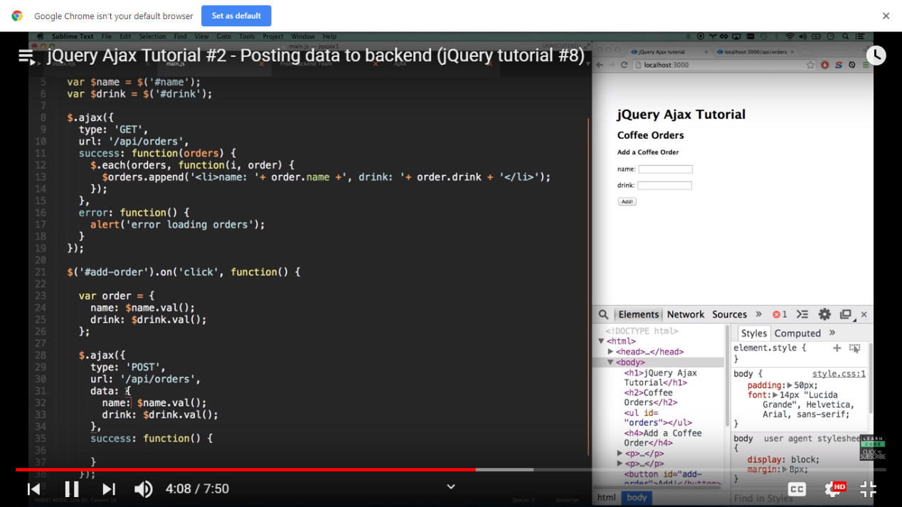

Tutorial 4

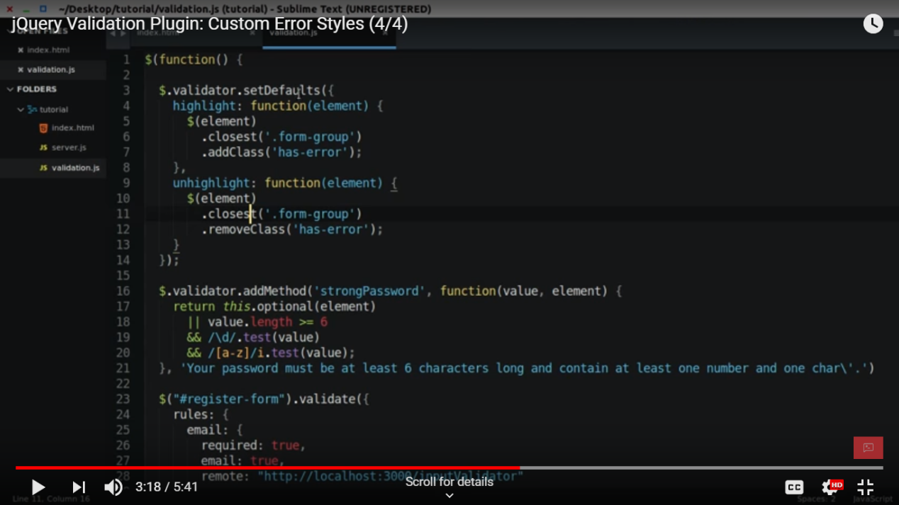

Now it will change the color of the error to red .

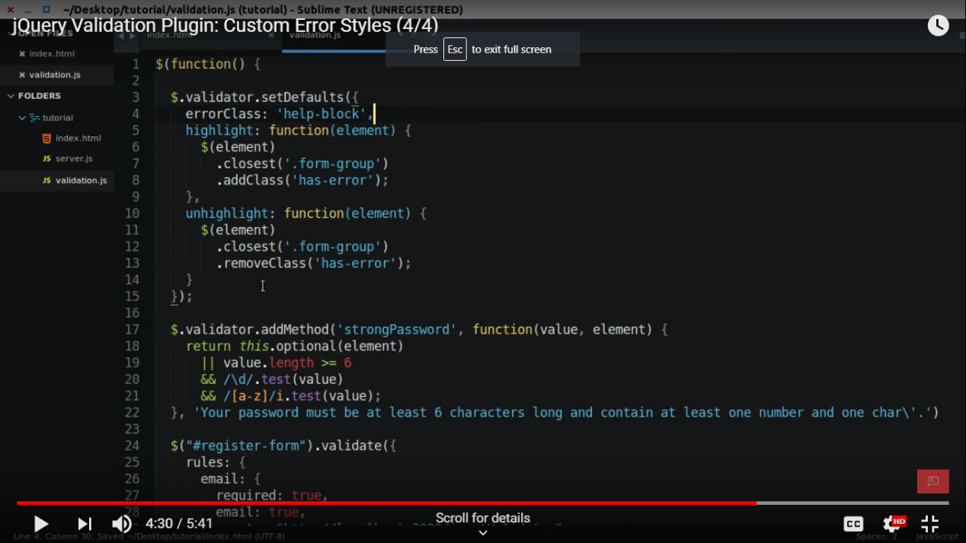

Now for the checkbox

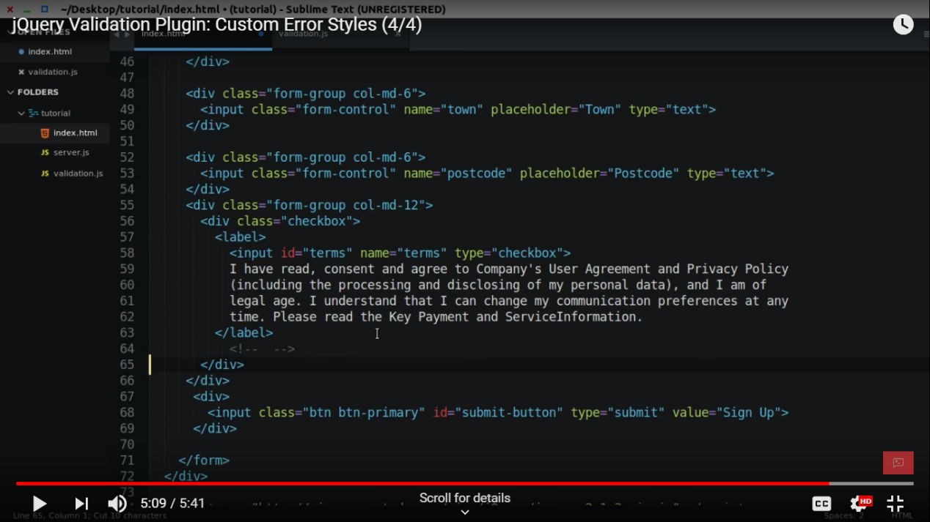

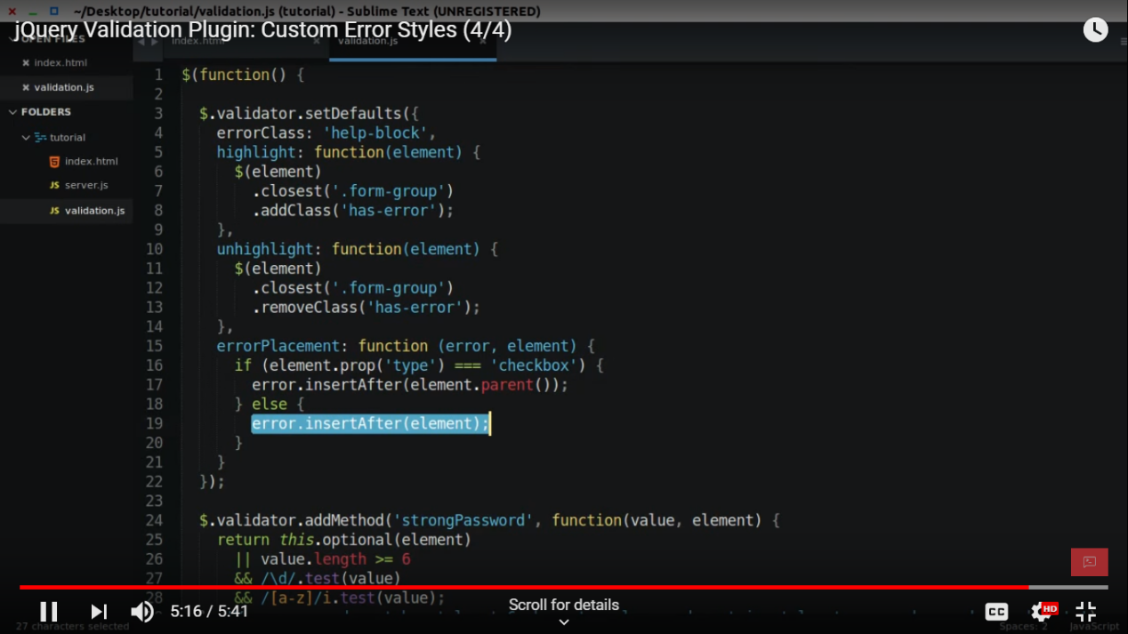

//////////////////

https://www.youtube.com/watch?v=xNSQ3i-BWMo

https://github.com/jquery-validation/jquery-validation

For implementing the addional method.js we need to add a file(we are checking username that contains only charcter, no white space )

* Js file(site link https://docs.microsoft.com/en-us/aspnet/ajax/cdn/jquery-validate/cdnjqueryvalidate1130)
* <https://ajax.aspnetcdn.com/ajax/jquery.validate/1.13.0/additional-methods.min.js>

/* pass must contain character ,digit | */

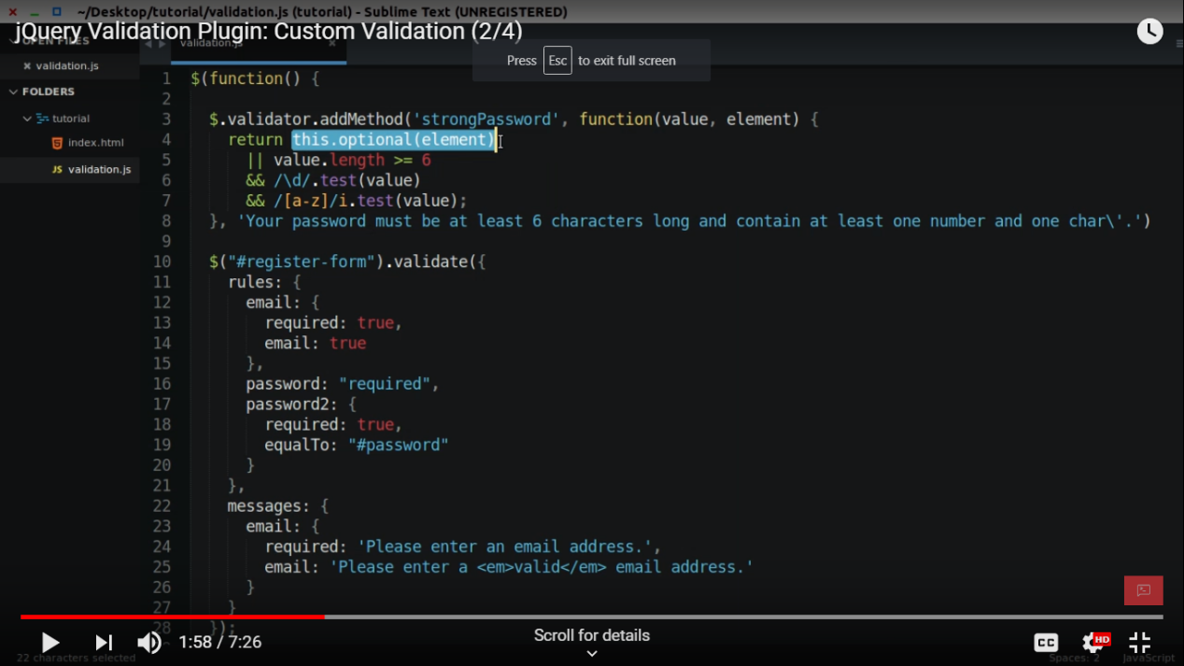

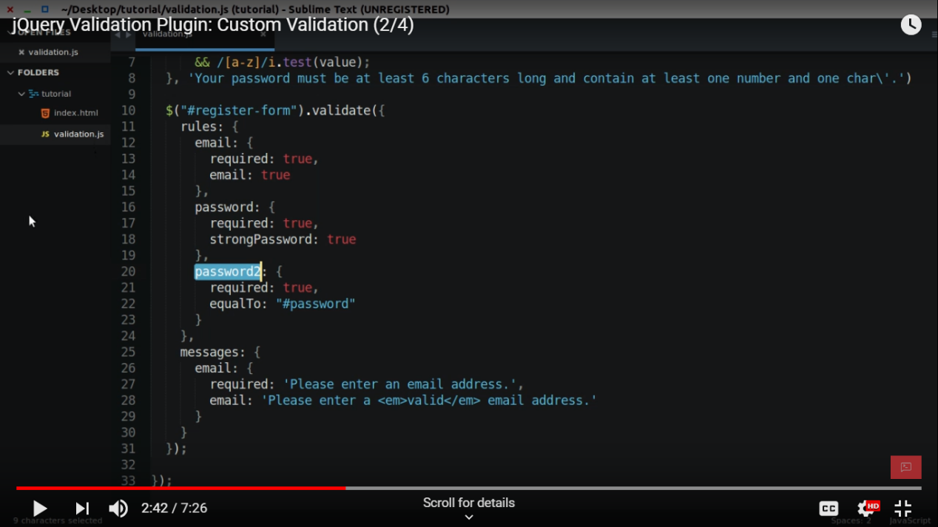

/**

<div>

<select id="eligiblebranch" name= "eligiblebranch" multiple="multiple" class="form-control" >

<option value="A">A</option>

<option value="B">B</option>

<option value="BB">BB</option>

<option value="AA">AA</option>

</select>

</div>

<div>

<input name="topic" id = "subject" placeholder="number" type="checkbox">car<br>

<input name="topic" id = "subject" placeholder="number" type="checkbox">van<br>

<input name="topic" id = "subject" placeholder="number" type="checkbox">santro<br>

</div>

<div>

*/

////

eligiblebranch:{

required:true

},

topic:{

required: "#subject:checked",

minlength:2

}

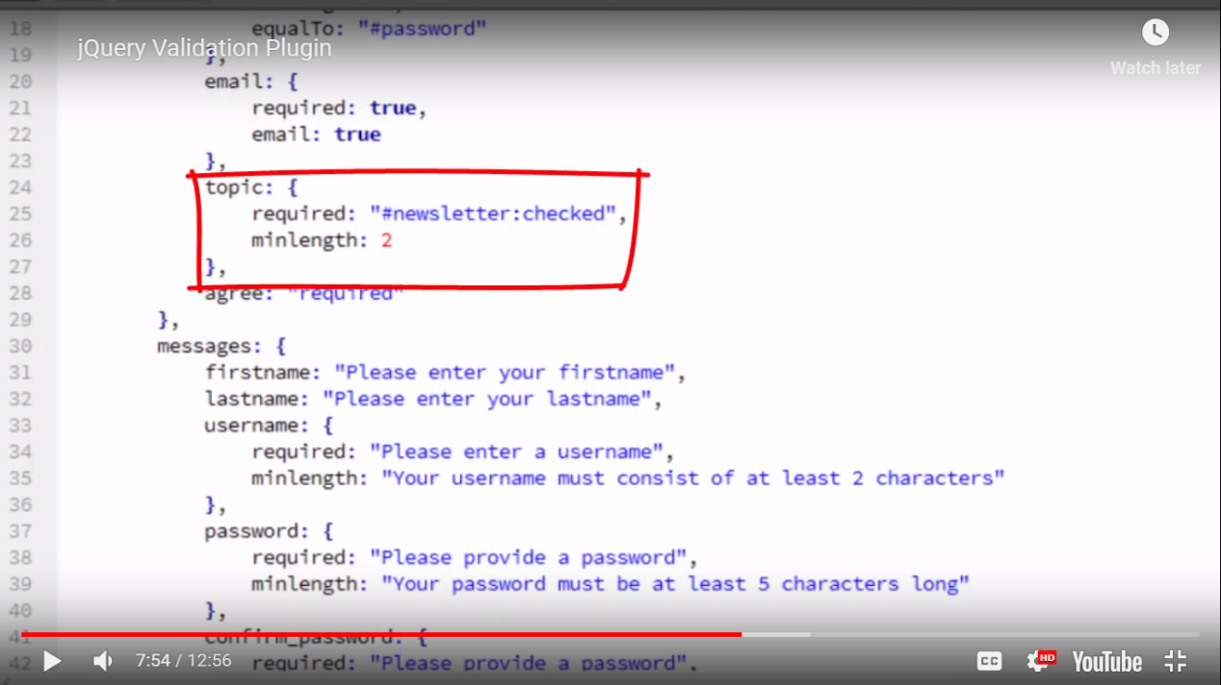

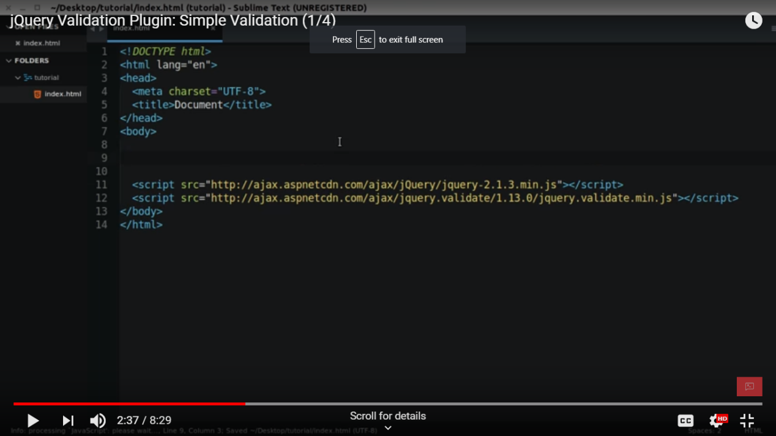

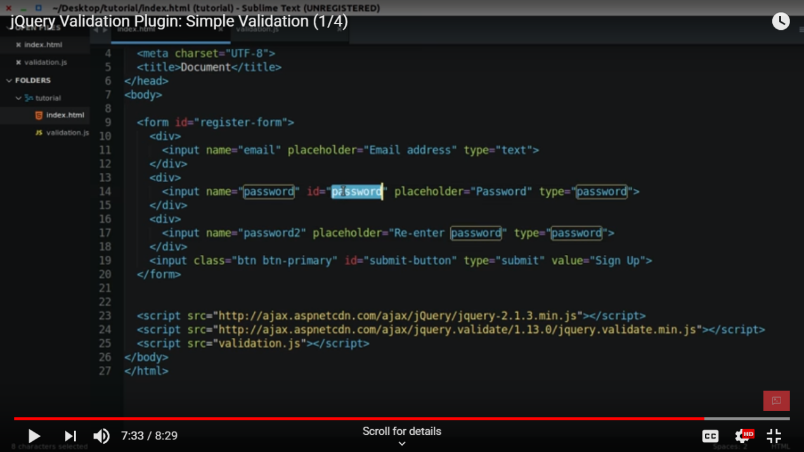

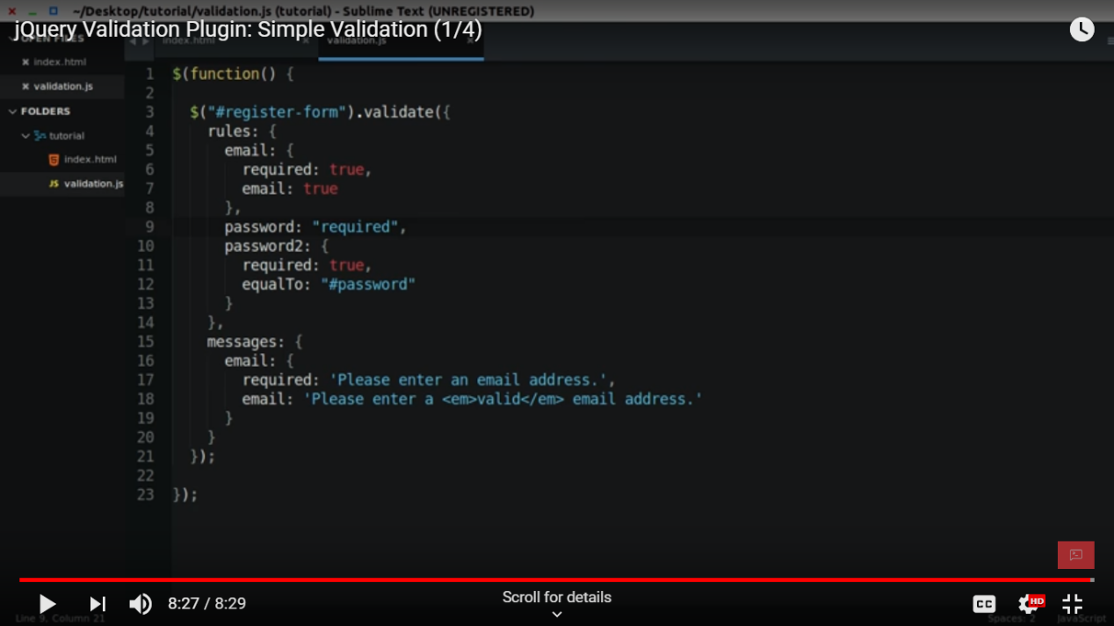

<!DOCTYPE html>

<html>

<body>

<form id="register-form">

<div>

<input name="email" placeholder="email" type="text">

</div>

<div>

<input name="password" id ="password" placeholder="password" type="text">

</div>

<div>

<input name="password1" placeholder="password1" type="text">

</div>

<div>

<input name="number" placeholder="number" type="number">

</div>

<input type="submit" name="submit">

</form>

<!--<script src="https://code.jquery.com/jquery-1.11.1.min.js"></script>

<script src="https://cdnjs.cloudflare.com/ajax/libs/jquery-validate/1.19.0/jquery.validate.min.js"></script> -->

<script src="https://code.jquery.com/jquery-1.11.1.min.js"></script>

<script src="https://cdn.jsdelivr.net/jquery.validation/1.16.0/jquery.validate.min.js"></script>

<script src="validation.js"></script>

</body>

</html>

///////////////////

$(function(){

$("#register-form").validate({

rules:{

email:{

required:true,

email:true

},

password:{

required:true,

},

password1:{

required:true,

equalTo: "#password"

},

number:{

required: true,

number:true,

maxlength: 4

}

},

messages:{

email:{

required: 'enter the email add',

email: 'valid valid'

},

password:{

required: 'enter the pass add',

},

number:{

required: 'atleast 10 digit',

number:'must be number',

maxlength: "4 digit number"

}

}

});

});